Centrelink Income Confirmation Consent
Authority Form
This consent will be used for the sole purpose of authorising Centrelink to provide your income details to Birribee Housing and the Aboriginal Housing Office. If you do not allow Centrelink to provide your information to us electronically, you will need to obtain this information from Centrelink yourself and provide it to us.

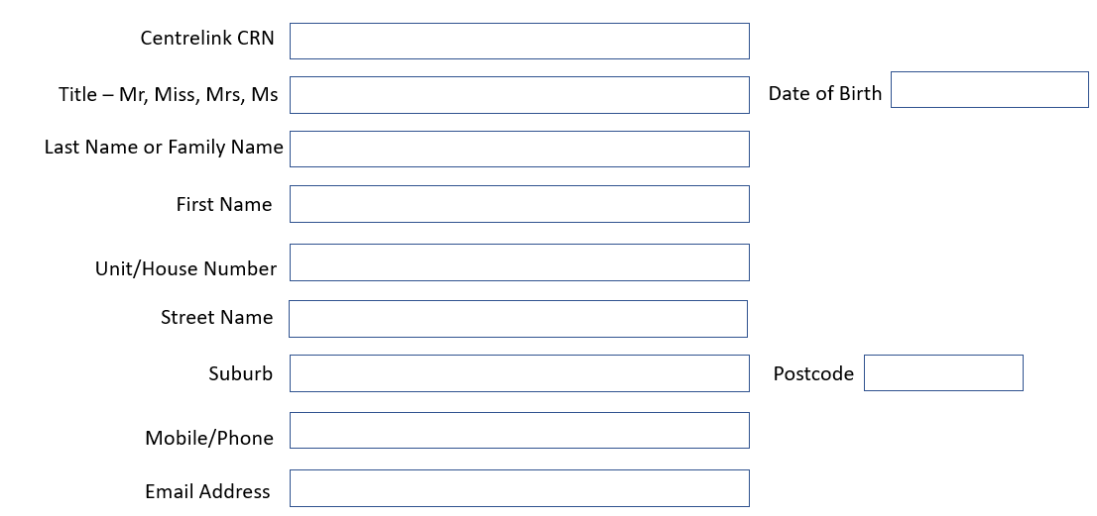
Income Confirmation Scheme Consent
Please read and sign the consent below.
- I understand Services Australia (the department) will disclose personal information to Birribee Housing and the Aboriginal Housing Office (AHO) hereafter referred to as the Property Manager and Owner (PMO) including my name, payment type, payment status, one off payments, income, assets, deductions, share care arrangements and partner status to confirm my eligibility for relevant housing service.
- I understand the PMO may disclose information contained in the Centrelink statement to a registered housing providers for the purpose of providing housing services.
- I understand this consent, once signed, remains valid while I am a customer of the PMO unless I withdraw my consent by contacting the PMO or the department.
- I understand if I withdraw my consent or do not provide proof of my circumstances/details, I may not be eligible for the housing services provided by the PMO.
- I understand I can get proof of my circumstance/details from the department and provide it to Birribee Housing and the PMO so that my eligibility for relevant housing service can be determined.
- I authorise Birribee Housing and PMO to use Centrelink Confirmation eServices to perform a Centrelink enquiry of my customer details in order to enable the business to determine if I qualify for a housing service.
- I authorise the department to provide the results of the enquiry to PMO.
Full Name: | Signature | Date
( |  | (DD/MM/YYYY)

More information about the Centrelink Confirmation eServices is available from a Centrelink office or on Centrelink’s
website at https://www.servicesaustralia.gov.au/

